# University Lesson Plan for *How’s My Waterway*

## Description

**Time**

* Background Reading: 10 Minutes
* Worksheet: Two Hours
* Extensions: 30 Minutes Each

**Learning Objectives**

At the end of this lesson, students will be able to:

* Describe a watershed.
* Learn about impaired waterbodies.
* See how different organizations are collecting data to help assess waterbodies.
* Collect evidence using an online environmental data tool.
* Construct an argument about how humans impact water quality.
* Evaluate different actions and design potential solutions to minimize human impacts to waterbodies.

Students will learn about their community’s watershed, explore data in the U.S. Environmental Protection Agency’s online How’s My Waterway tool, and uncover information about the health of their waterways. Internet access is required.

## Materials

* University Lesson Plan
* Background & Key Features Information Sheet
* How’s My Waterway Worksheet
* Three Extension Activities – Spotlight on: 1) Environmental Justice, 2) Action, and 3) State Water Quality

## How to Teach this Lesson Plan

This lesson can be presented in-class or as homework. For an in-class lesson, have students explore the tool and fill out the *How’s My Waterway Worksheet* individually or in groups. You can also ask students to fill out the worksheet as homework and then devote a class session to a presentation and discussion of students’ work. Additional reading information about the tool is provided for both instructors and students in the *Background & Key Features Information Sheet*.

## In-Class Activity

*NOTE: Instructors can tailor students’ exploration of the tool according to available class time. You can choose to complete all the questions in the worksheet or focus on a smaller subset of questions. Students can complete the worksheet individually or in groups.*

1. If teaching in person, project the How’s My Waterway home page (https://mywaterway.epa.gov/) on the board for students; if teaching virtually, share the home page on your screen. Explain that students will be using the tool to explore the condition of their local waterways. Click through the tool’s interface and main features (see the *Background & Key Features Information Sheet* for an overview of How’s My Waterway).
2. After all students complete the *How’s My Waterway Worksheet*, ask for volunteers to share their responses to the last two questions and/or the bonus question.
3. In addition to the *How’s My Waterway Worksheet*, we have included three extension activities at the end of this document that can be assigned as homework or done in small groups during additional classes.

# HMW Background & Key Features

## Background

A [watershed](https://www.epa.gov/hwp/basic-information-and-answers-frequent-questions) is the land area that drains into a specific stream, creek or small river, or into a larger waterbody such as a lake, larger river or estuary —all of which eventually lead to the ocean. Although watersheds share similarities, all of them are different. Some are as small as a [footprint](https://www.usgs.gov/special-topic/water-science-school/science/watersheds-and-drainage-basins?qt-science_center_objects=0#qt-science_center_objects), while other large watersheds —for example, the Mississippi River watershed which spans thousands of miles and 33 states —are made up of many smaller watersheds.

We all live in a watershed, and every inch of land in the United States drains into a waterbody. That means what we do on land directly affects the quality of our surrounding waterbodies. It also means we’re all responsible for protecting the health and quality of our watersheds.

A [healthy watershed](https://www.epa.gov/sites/production/files/2015-10/documents/2009_08_05_nps_healthywatersheds_highquality_hwi.pdf) has mostly natural land cover, especially near its waters; good water quality, quantity, and flow; and habitats that support aquatic life like fish, water bugs, plants, and other animals. You might not realize it, but all of us benefit from healthy watersheds in many ways. Without healthy watersheds, we wouldn’t have access to critical services like clean drinking water, productive fisheries, and outdoor recreation—all of which support our environment, quality of life, and economies.

Despite their importance, healthy watersheds are uncommon in the United States, often because of human activities on land, such as agriculture, urbanization, and waste disposal. That’s because human activities may alter the land or create pollutants that degrade water quality, thereby stressing aquatic life and limiting human water uses like swimming, drinking, or eating fish. For example, after it rains runoff of nutrients like nitrogen and phosphorus from lawn fertilizers can lead to harmful algae growth, or discharge from industrial or wastewater plants into waterways can lead to contaminated sediment.

The U.S. Environmental Protection Agency (EPA) has been working with states for decades to protect and restore watersheds across the country to achieve the [Clean Water Act](https://www.epa.gov/laws-regulations/summary-clean-water-act) goal of restoring and maintaining, “the chemical, physical, and biological integrity of the Nation’s waters.“ When the quality of a waterbody no longer supports its designated uses assigned by the state (e.g., aquatic life, recreation, drinking, or fishing), a state must report it as an “impaired water” to the EPA. EPA requires states with impaired waters to develop a [Total Maximum Daily Load](https://www.epa.gov/tmdl/overview-total-maximum-daily-loads-tmdls) (TMDL) restoration plan. A TMDL is the maximum amount of a pollutant allowed to enter a waterbody so that the waterbody will meet water quality standards for that pollutant under the Clean Water Act. By setting a TMDL, states have a pollutant reduction target—sometimes called a “pollution diet”—to work toward.

Because TMDLs focus on restoring water quality in waterbodies *after* they’ve become impaired, EPA created the [Healthy Watersheds Program](https://www.epa.gov/sites/production/files/2015-10/documents/2009_08_05_nps_healthywatersheds_highquality_hwi.pdf), which takes a proactive approach to protecting high-quality waters. The Healthy Watersheds Program collaborates with citizens, states, territories, tribes, other government agencies, and private partners to assess and protect watersheds by addressing *future* threats such as:

* Emerging water quality problems
* Loss and fragmentation of aquatic habitat
* Altered water flow and availability
* Invasive species
* Climate change

EPA also protects watersheds by developing scientifically sound and consistent data sources that provide reliable information about waterbody conditions, pollution sources, and factors that might influence efforts to restore and protect water quality. One of those data sources is the *How’s My Waterway* online tool. Using *How’s My Waterway,* we can find out what’s happening to water quality in our community, our state, or even the entire country.

## Key Features

**Getting Started**

The tool presents information about waterbody condition on three scales: community, state, and local. It provides information about impairments to designated water uses for swimming, eating fish, aquatic life, and drinking water. For any given location, you can explore these topics to learn how about waterbodies that have been assessed and if they are in good or impaired condition, or if their condition is unknown.

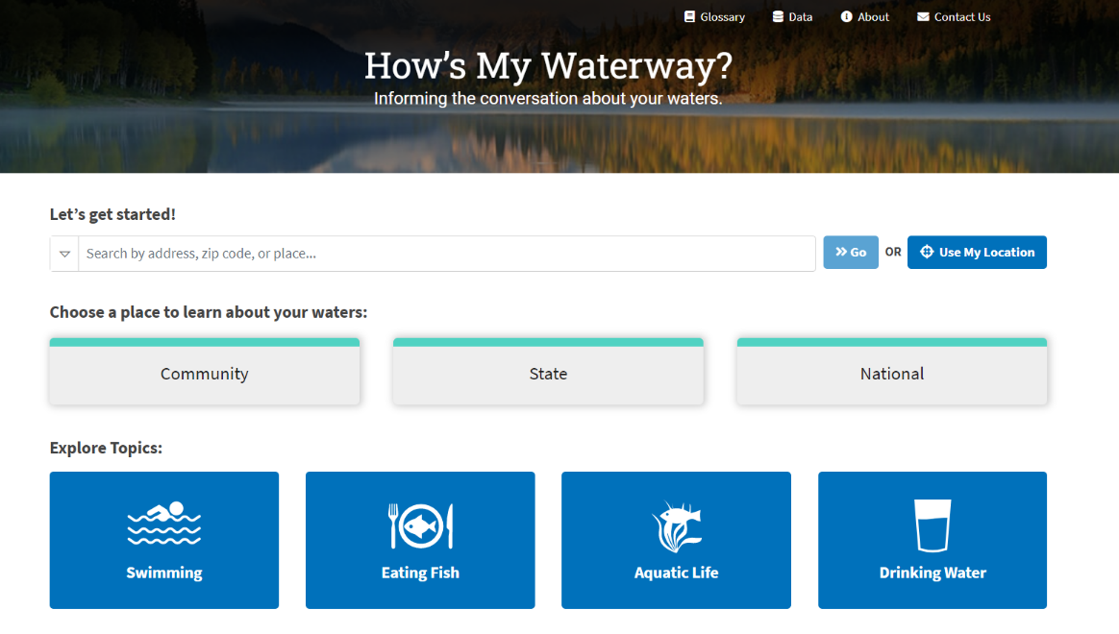

**Overview Page**

The left side of the page shows a map of the selected watershed with waterbodies and their conditions. Clicking a waterbody reveals a popup with the waterbody’s name, condition (good, impaired, or unknown), what the water is used for, conditions, and identified issues (if applicable). The right side of the page provides the same information in a list.

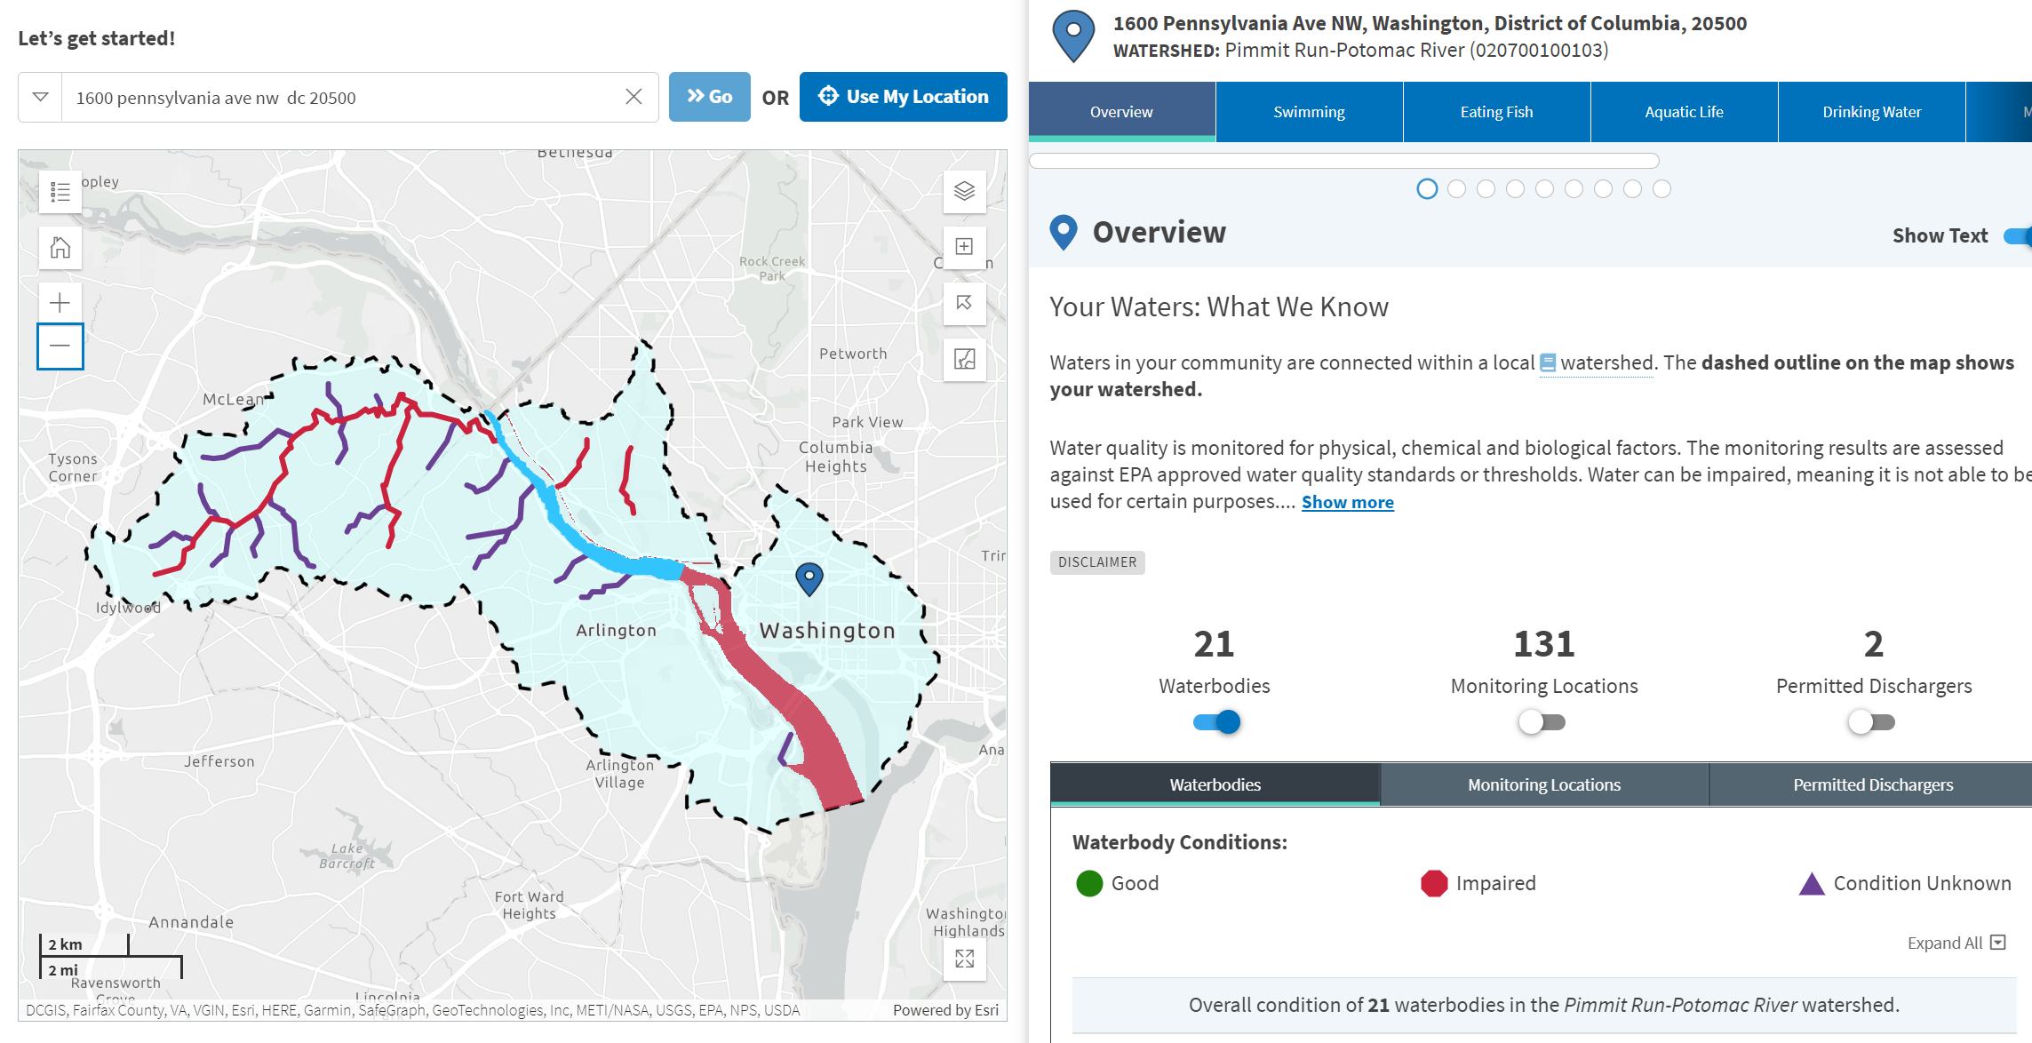Clicking on the blue tabs on the top right of the page provides users with summary information for waters within the selected watershed. This includes overview information on swimming, eating fish, aquatic life, and drinking water, monitoring locations, identified issues including discharges with significant violations, efforts underway to restore waters, and protection projects or protected areas in the watershed. You can toggle on and off three parameters: waterbodies, monitoring locations, and permitted dischargers.

**Monitoring**

This tab lets you see water monitored by different organizations in two sections: current water conditions and past water conditions. You can sort by different characteristic groups. On the map, you can see current water conditions (yellow circles) and past water conditions (purple circles). Clicking on each of these icons provides a popup box with more information about these locations, includes the organization name, location, water type, number of samples, monitoring measurements, and monitoring data.

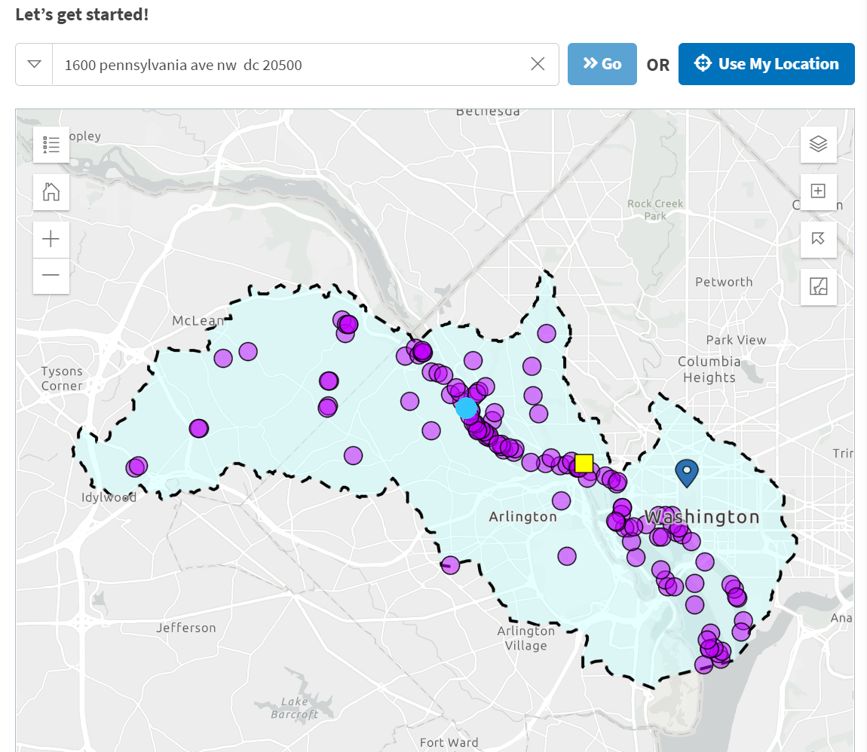

**Identified Issues**

This tab provides information about the percent of waters impaired in an area and dischargers with significant violations. It provides a list of impairment categories in a watershed. Categories can be toggled on and off.

**Restore and Protect**

The “Restore” tab shows any EPA-funded projects or restoration plans underway for the watershed. The “Protect” tab shows watershed health scores, the location of designated wild and scenic rivers, and if there are any protected areas or projects underway.

**Toggle (see Overview Tab): Permitted Dischargers**

This tab provides the names and National Pollutant Discharge Elimination System (NPDES) numbers of permitted dischargers in the area. The NPDES program regulates [point sources](https://www.epa.gov/npdes/npdes-permit-basics) that discharge pollutants to U.S. waters. Learn more about NPDES [here](https://www.epa.gov/npdes).

# How’s My Waterway Worksheet

Go to the How’s My Waterway home page (<https://mywaterway.epa.gov/>). Enter the address, “1600 Pennsylvania Avenue NW, Washington, DC 20500”, in the box under “**Let’s get started!”**, then click on the “**Overview”** tab. The dashed outline on the map shows your watershed.

**Overview Tab**

1. What is a watershed?
2. What is a Hydrologic Unit Code (HUC)? Hint: HMW includes a Glossary at the top right of the page (search: HUC).
3. What is the name and 12-digit HUC of your watershed? Hint: The HUC number is located to the right of the watershed name.

Name:_________________________________ HUC: ________________________________

1. How many waterbodies are in this watershed?
2. Scroll through the list of waterbodies (or use the map) and select up to five impaired waterbodies. Fill out the chart below for each waterbody selected (list up to 5 waterbodies).

|  |  |  |  |
| --- | --- | --- | --- |
| **Name of Waterbody** | **Year Last Reported** | **What is this water used for?** | **Identified Issues** |
|  |  |  |  |
|  |  |  |  |
|  |  |  |  |
|  |  |  |  |
|  |  |  |  |

1. Click on the **Potomac DC** (District Waterbody ID: DCPMS00E_02) portion of the waterbody (outlined in blue on the map). Then click on the **Waterbody Report** for this location. Fill out the chart below with the water quality issues that have been identified for this waterbody and the probable sources contributing to impairment (Note: some states do not provide information on probable sources).

|  |  |  |
| --- | --- | --- |
| **Impaired Designated Use** | **Impaired Parameter(s)** | **Probable source(s) contributing to impairment** |
|  |  |  |
|  |  |  |
|  |  |  |
|  |  |  |
|  |  |  |
|  |  |  |

**Overview Tab**

1. Return to the Overview Tab. Who are the permitted dischargers for this watershed? Do any of the dischargers have violations? If yes, navigate to the facility report. On the facility report page, what is the name of the statute(s) that the discharger has violated (Hint: See the *Enforcement and Compliance Summary* table)? Next, list the specific pollutants and date ranges associated with the violations (**Hint:** Review the *Three-Year Compliance History by Quarter* table).
2. Click on the arrow shown to view the upstream watershed. Then click inside the upstream watershed to change your location. Can you find anything happening in the upstream watershed that may be affecting your waters downstream?

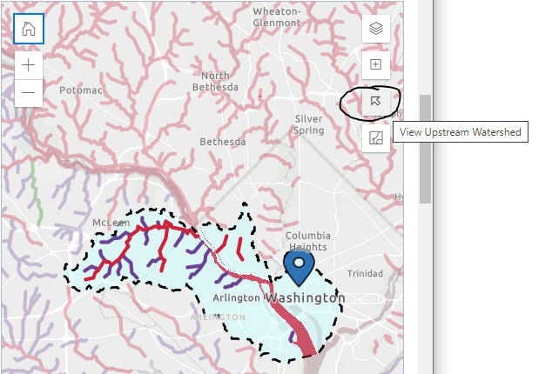

1. On the overview tab, how many monitoring locations are there in this watershed? Toggle on the current water conditions. What is the latest measurement for gage height (water level)?

**Monitoring Tab**

1. Navigate to the monitoring tab. Name 3 different organizations monitoring in the area. What characteristic groups are being monitored by each organization?
2. How many locations have sampling data on **nutrients**? What about **metals**?
3. Click on the sample location for Foundry Branch (monitoring site ID TFB02; see blue highlighted circle on the map below).

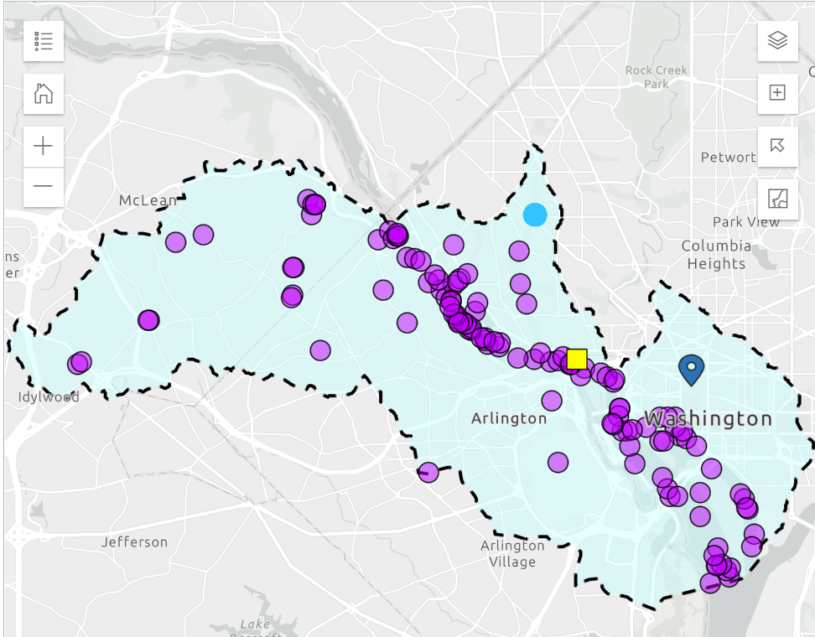

**Click here**

1. How many samples are collected here and what types of samples are collected?
2. Download the .xls data for this sampling location. How long has sampling been in place in this location and what is the frequency of collection? (**Hint:** Review the data within the *activity state date* column)
3. Why is monitoring important?

**Restore Tab**

1. What Clean Water Act Section 319 projects are underway to address the impairments for this waterway? Pick two projects and describe the impairment it is addressing and its objectives.

|  |  |  |
| --- | --- | --- |
| **Project** | **Impairment Targeted** | **Project Objectives** |
| 1. |  |  |
| 2. |  |  |

1. How many Restoration Plans are in place for this watershed?
2. What is a TMDL and how does it help restore water quality?
3. Find a plan with a TMDL. Click on “Open Plan Summary”, what details can you find out about this particular TMDL?

**Protect Tab**

Navigate to the protect tab (you will need to toggle on and off each of these layers separately on the right side of the page).

1. Find your watershed health score. Is it more healthy or less healthy than other watersheds in your state?

Are there any protected areas? Find and list 3 protected areas and who manages them. . Are these areas publicly accessible?

**What can you do?**

1. List three things you can do to restore and protect your watershed. What actions will you take in the future to inform your community about what a watershed is and how to protect it? (**Hint:** Look at the *tips* section of the protect page and the *glossary* at the top right of the page to learn about what you can do about impairments in your watershed.)

**Bonus Question**

Find a wild and scenic river somewhere near where you live, or somewhere that you have visited. What is the name of the river? Why are wild and scenic rivers important?

# Extension 1: Spotlight on Environmental Justice (Homework or Group Activity)

Environmental justice is a term that means everyone should be able to live a healthy life in a safe and protected environment regardless of their race, color, national origin, or income. Unfortunately, some people in the United States live in places that have unhealthy environments, such as near a chemical plant that is emitting pollutants into the air or in buildings that have old lead pipes that are wearing away and letting lead, a toxic metal, enter people’s drinking water. Research a community in the United States that has experienced disproportionate, negative impacts to water quality in its watersheds. [Potential communities that teachers can assign include Flint, Michigan; Fresno, California; Jacksonville, Florida; Houston, Texas; and Pittsburgh, Pennsylvania].

Develop a case study that answers:

* Who is affected?
* How are they impacted?
* Why does the problem exist?
* How did the community respond?
* What more could be done?
* Include data about the watershed in that community from the *How’s My Waterway* tool. To obtain this information, go to the *How’s My Waterway* homepage and type in the name or zip code of the community. When the map appears, click on the “layers” icon on the top right corner of the map. Then, scroll to the bottom of the list and click “Demographic Indicators.”

The map will now display areas with environmental justice concerns in yellow, orange, and red. Communities in red areas are the most vulnerable to environmental inequalities.

What can you learn about the people living in or near your watershed? Is there a large concentration of historically underrepresented communities there? Pick three areas with environmental justice concerns and describe the following:

* Watershed name
* Demographics information
  + Percent Minority
  + Percent Low Income
  + Percent Less Than High School Education
  + Percent Linguistically Isolated
  + Percent Individuals Under 5
  + Percent Individuals Over 64
* Impairments to swimming
* Impairments to eating fish
* Impairments to aquatic life

# Extension 2: Spotlight on Action (Homework or Group Activity)

Identify an impaired waterbody in a watershed of your choice. Develop a presentation (e.g., in Google Slides) to convince members of your community to take action to restore the health of their waters. Using *How’s My Waterway* as your data source, answer the following questions in your presentation:

* What issues are affecting these waterways?
* How do these issues affect the community’s swimming, fish consumption, and aquatic life?
* How are community members contributing to the problem? Should we give a hint to click on the issues definitions in the glossary?

After identifying the issues and their causes, develop a checklist of things people can do to reduce and prevent these issues in the future.

# Extension 3: Spotlight on State Level Water Quality (Homework or Group Activity)

Using the “State” tab in How’s My Waterway, investigate the quality of water in your state. Learn about different types of waterbodies and their condition. Develop a presentation (e.g., in Google Slides) to summarize your findings. Using *How’s My Waterway* as your data source, answer the following questions in your presentation:

* How many miles of each assessed water type are in good, impaired, or unknown condition. Use the bar charts generated from the tool in your presentation.
* What designated water uses are impaired in the state for different waterbody types?
* What are the main reasons why these waters are impaired?
* Research at least two efforts being done in your state to help protect and restore waters (see “Water Stories” and “Documents” in the tool for help).